DBMS Technical Task
Dhanalakshmi K
E25AI110
BSc. Computer Science
With
Artificial Intelligence

Week 7: SQL Query Implementation for E-Commerce Database
The e-commerce company has collected customer, product, order, and inventory data. The management team wants to retrieve useful information from the database for daily operations and basic business analysis.

- Perform Basic SQL Queries

- Display all customer details.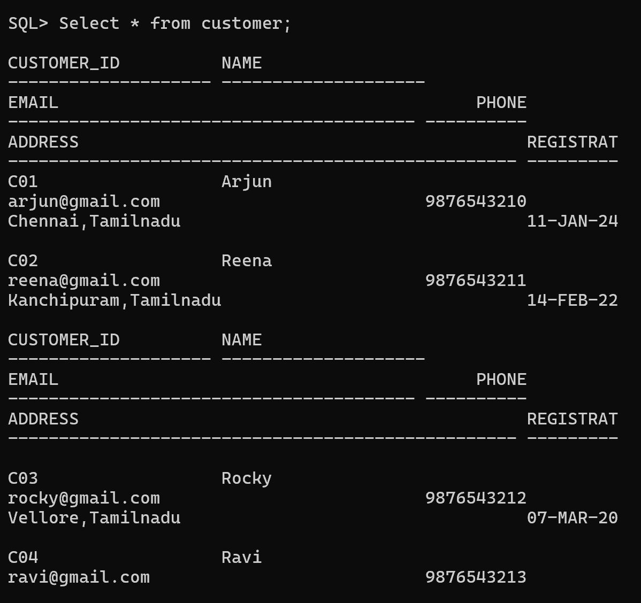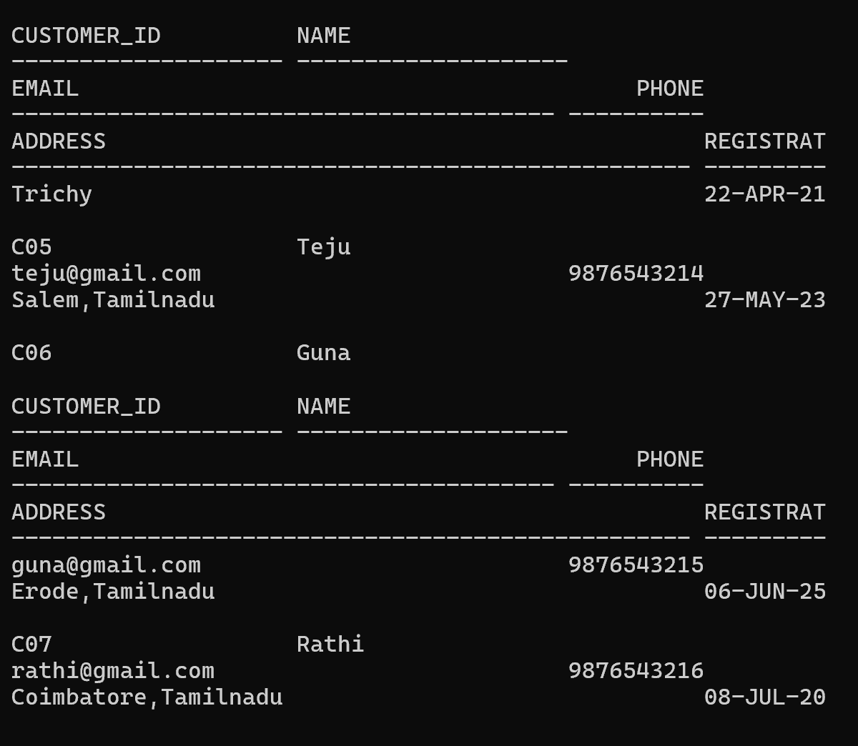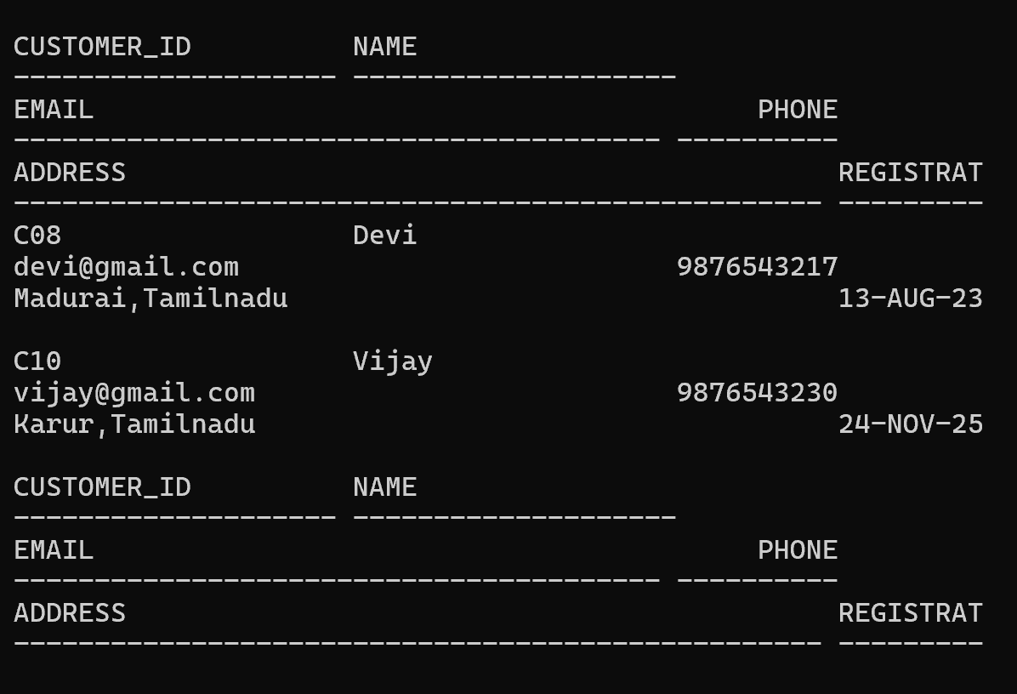

- Display all available products.
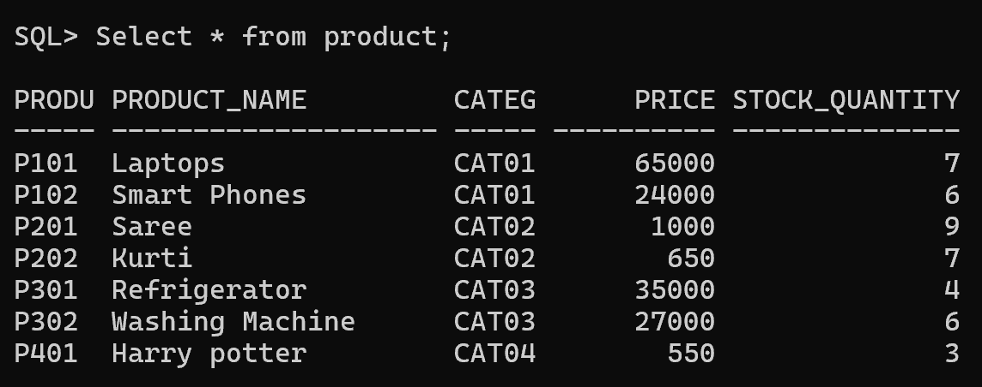

- Retrieve product names and prices only.
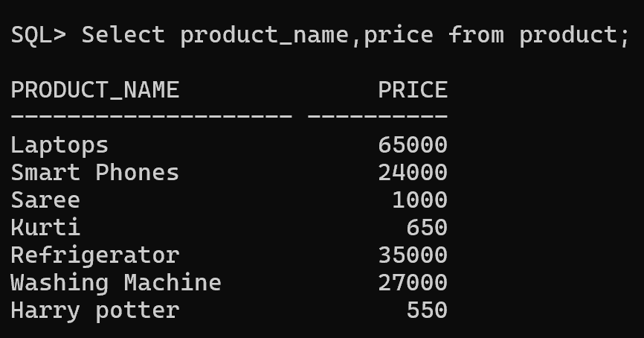
- Display all orders placed by customers.
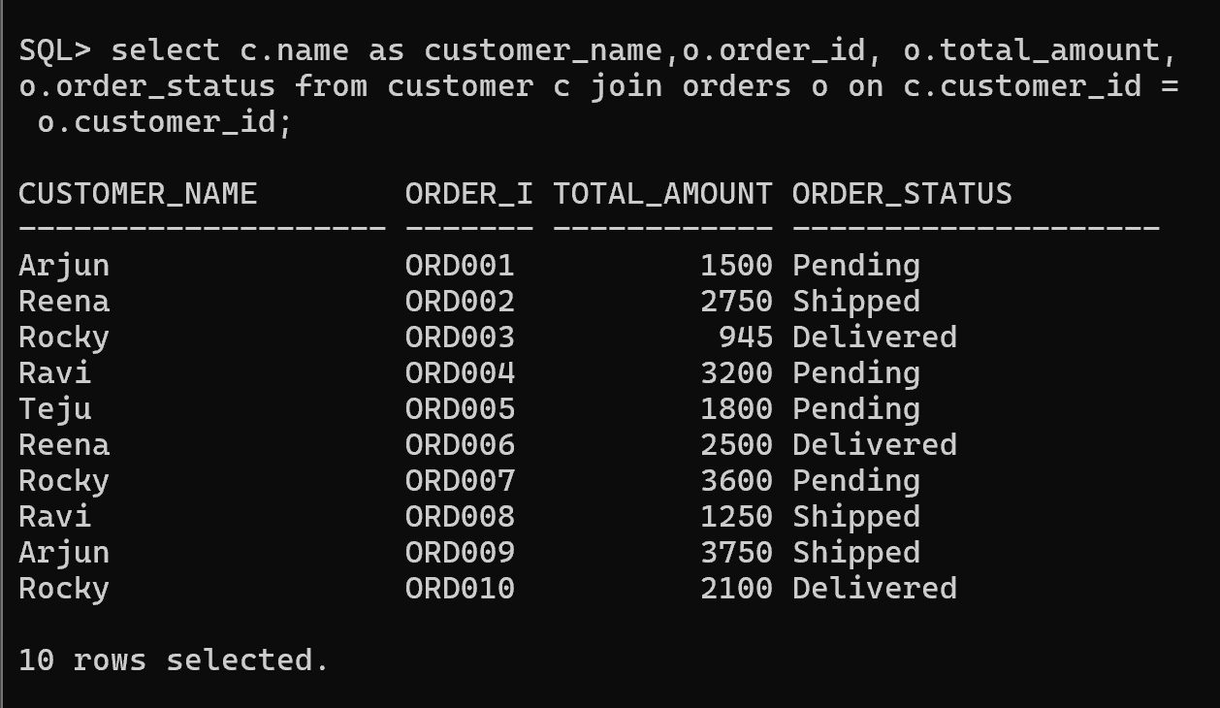

- Retrieve payment details.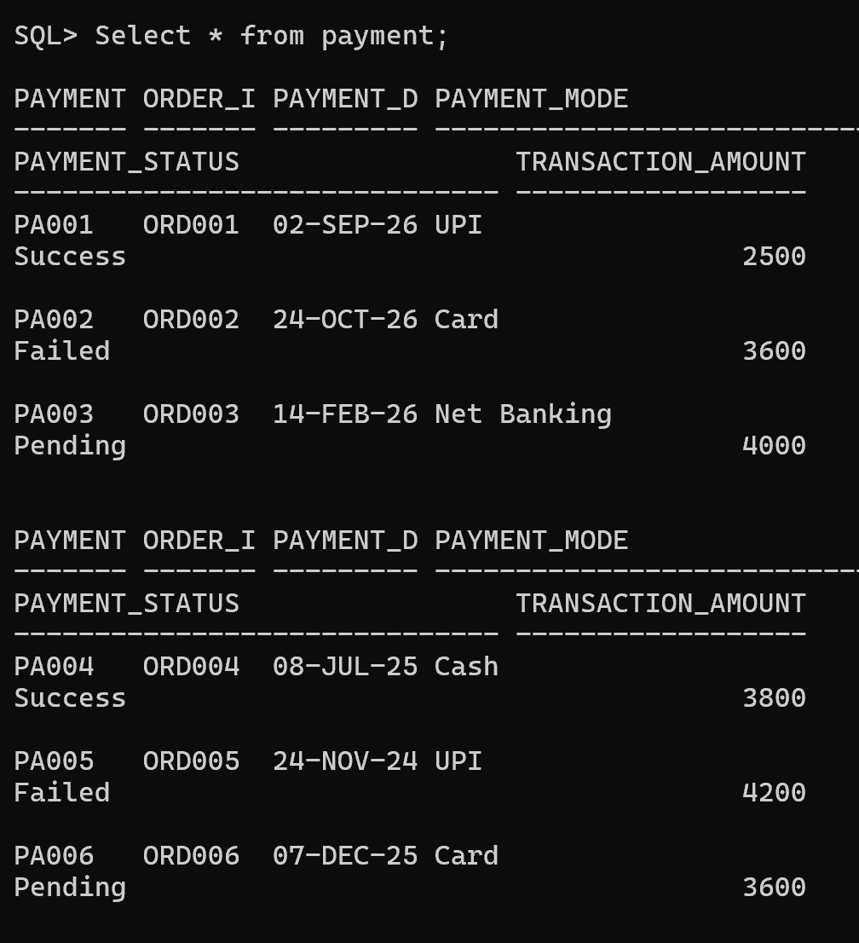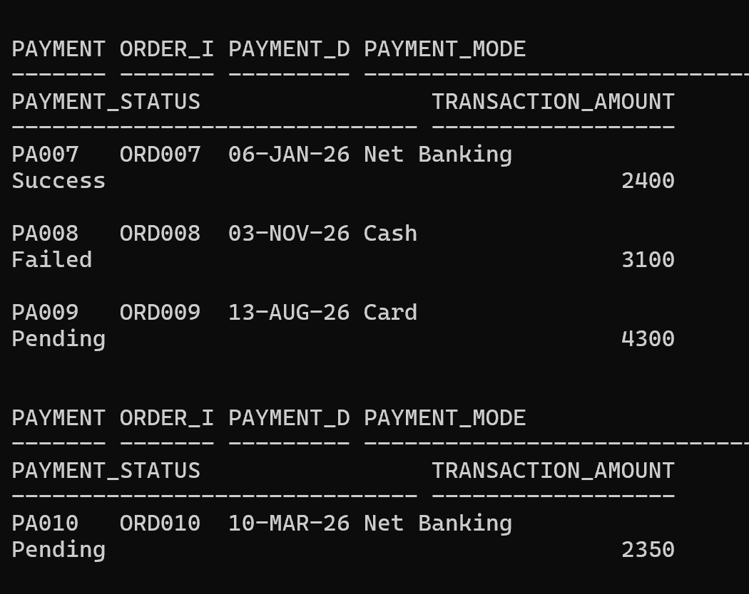
- Apply Filtering Conditions Using WHERE
- Find products with price greater than ₹5000.
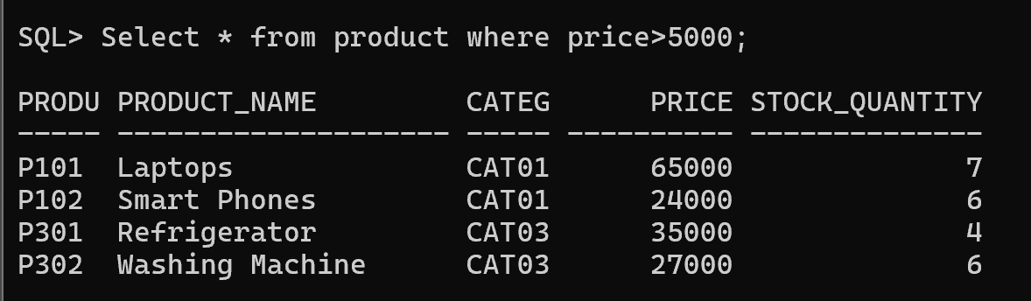
- Display products available in stock.
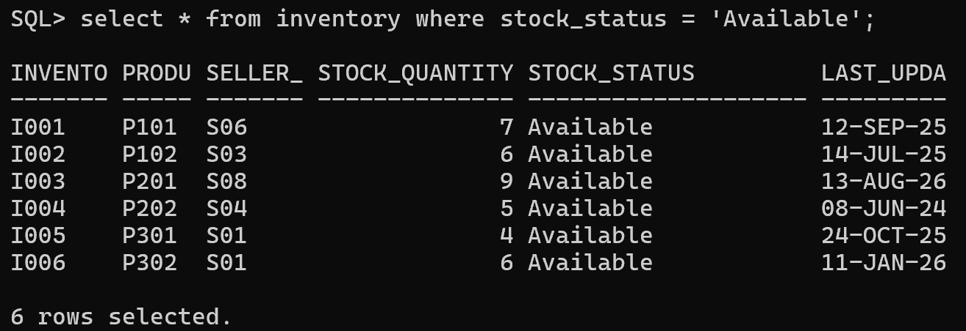
- Display completed orders.
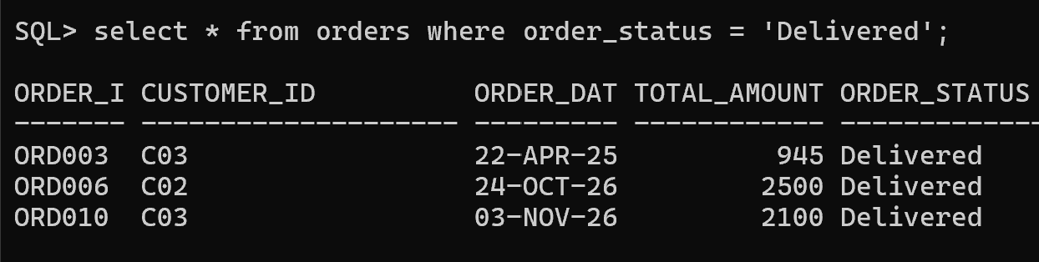
- Find products with rating above 3.
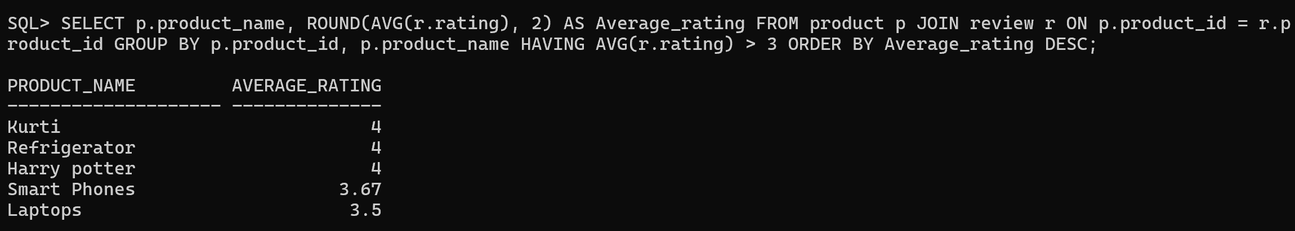

3.Sort Data Using ORDER BY
- Display products from lowest to highest price
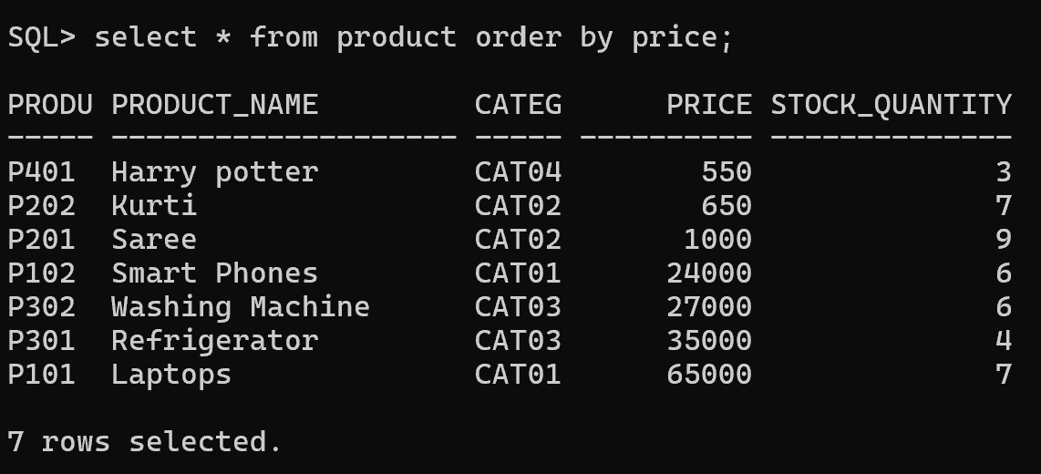
- Display customers alphabetically.
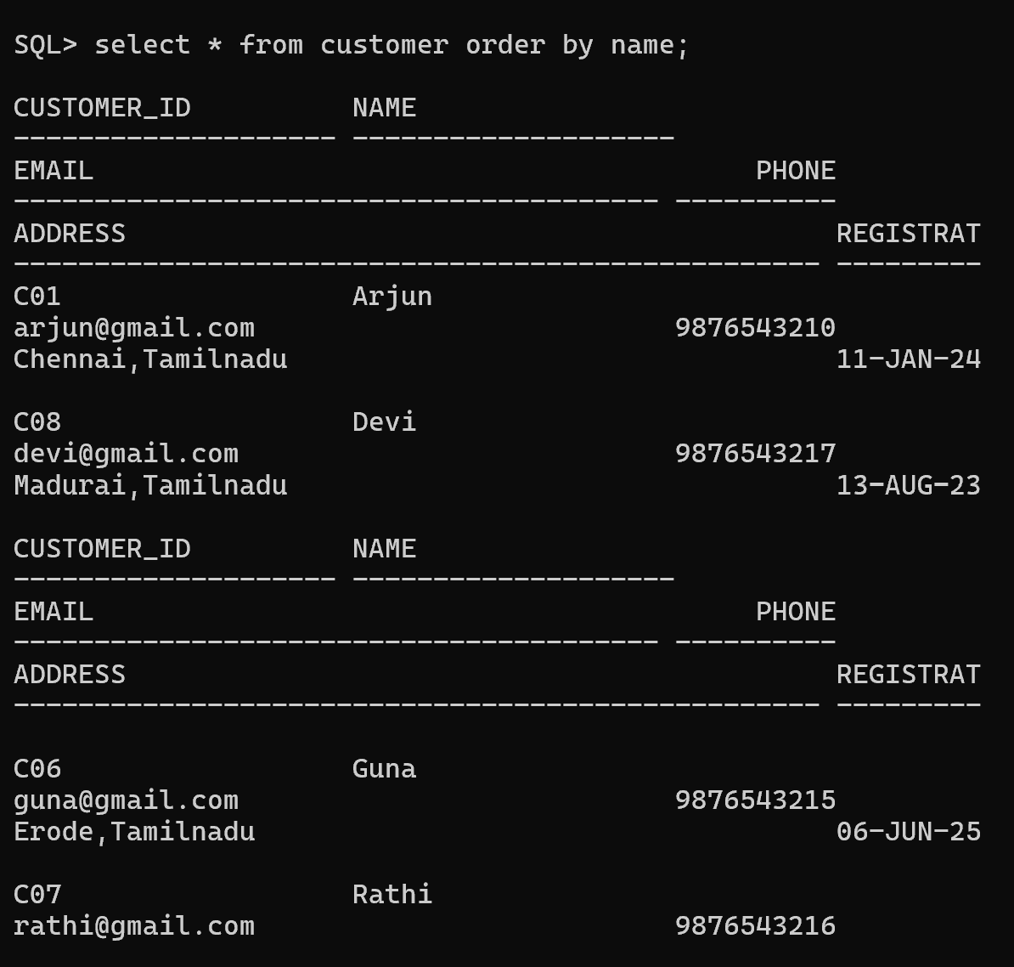
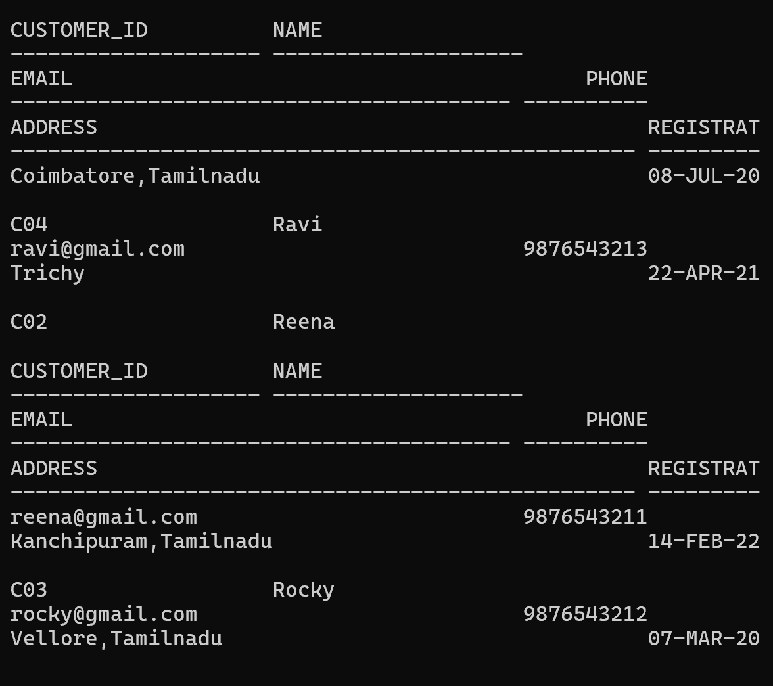
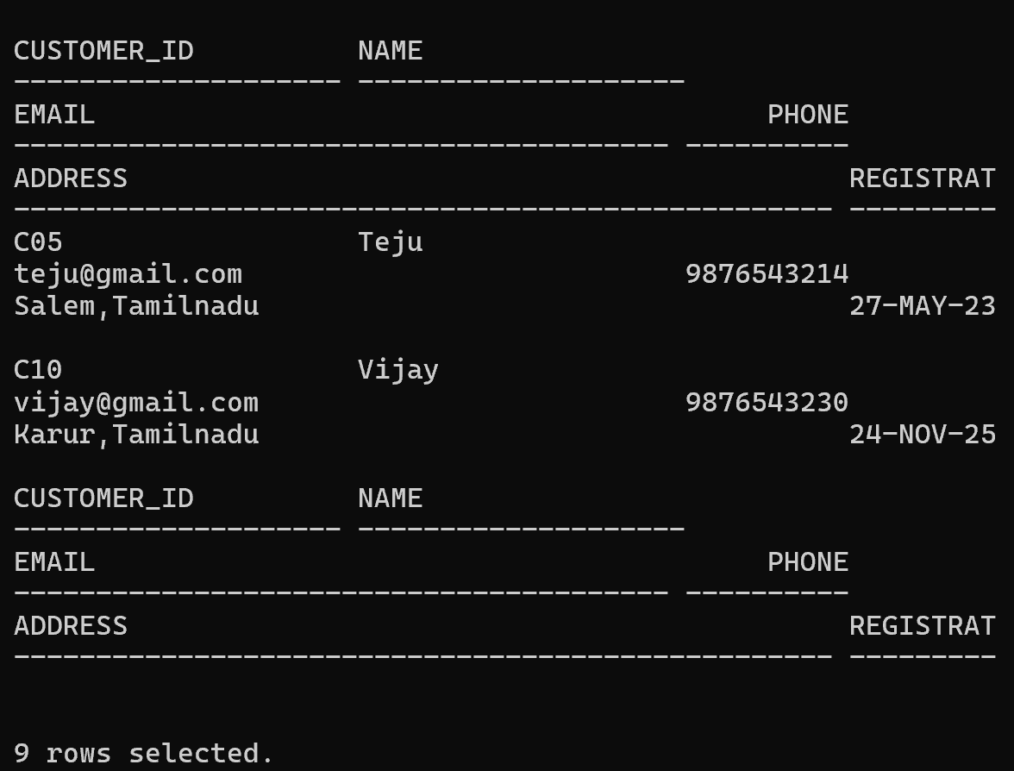
- Find top expensive products.
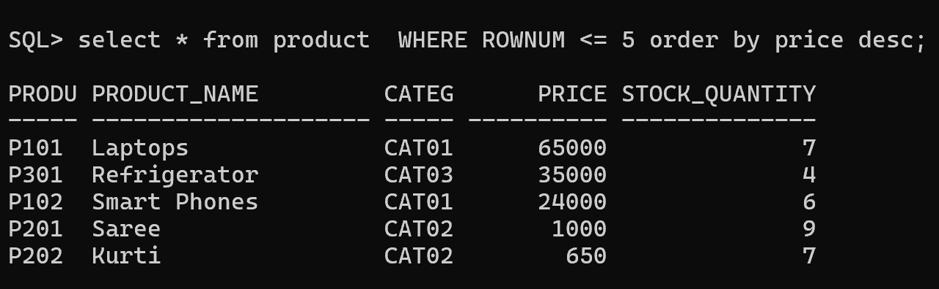
- Display latest orders first.
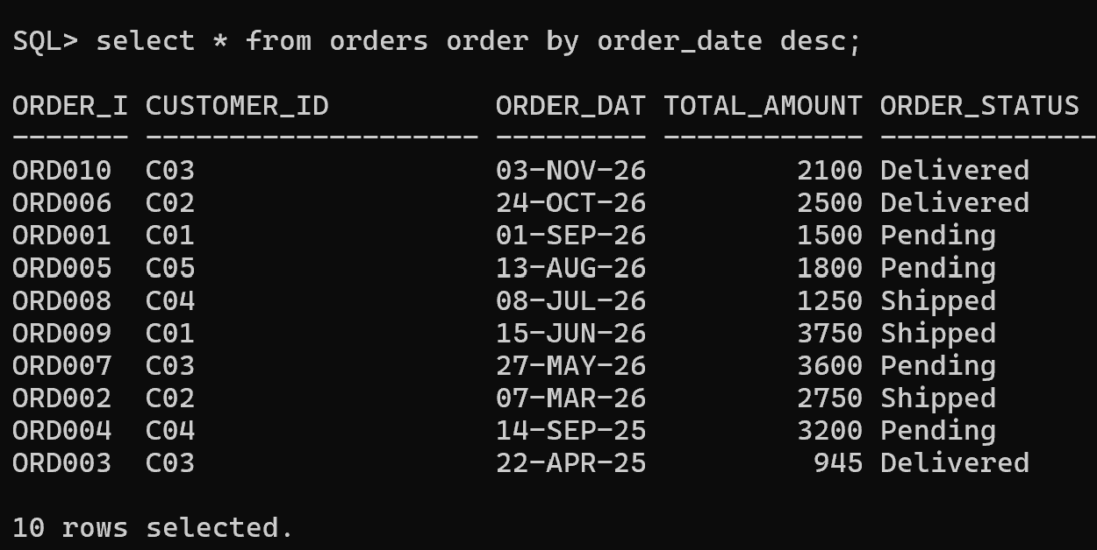

4.Retrieve Unique Values Using DISTINCT
- Display unique product categories.
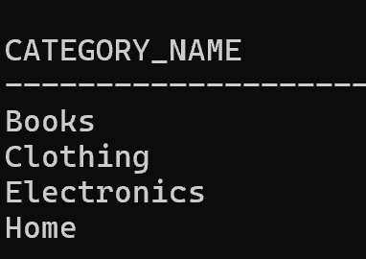
- Find different payment methods used by customers.
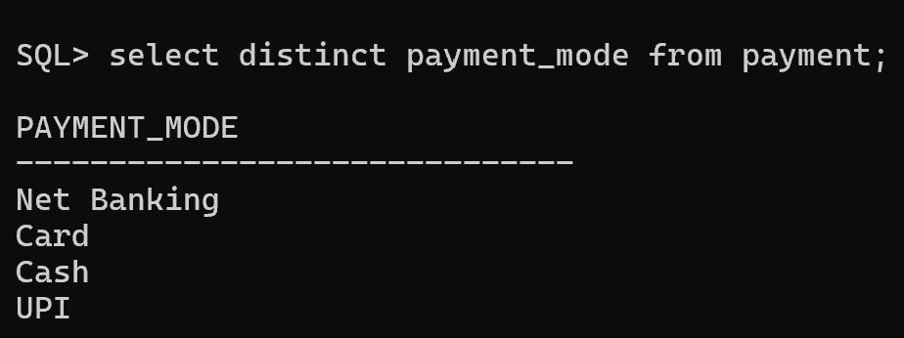

5.Search Products Based on Conditions
- Find products within a specific price range. (Product Between 20,000 to 40,000)
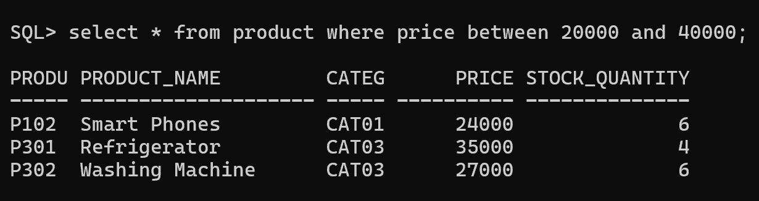
- Display products belonging to a particular category.
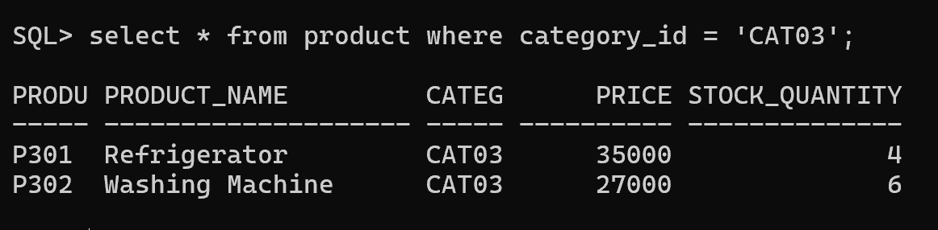
- Find products currently available in inventory.
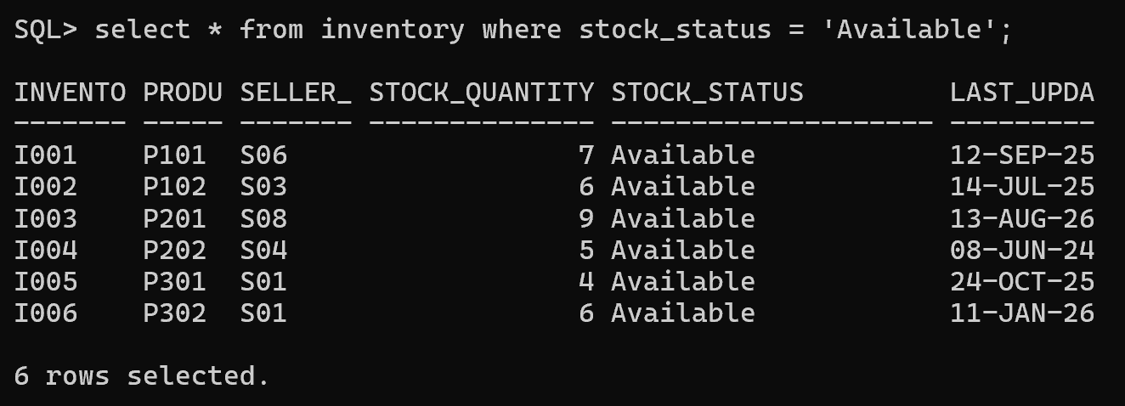
- Search products using product name.
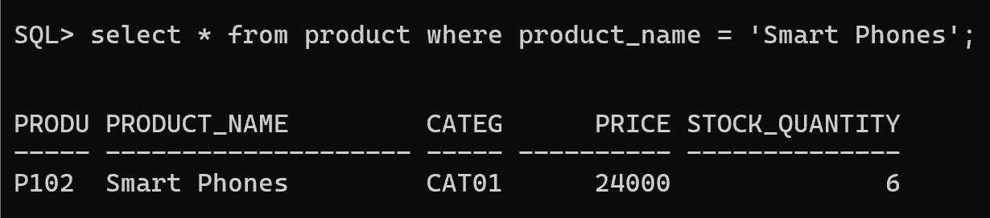
- Find low-stock products.
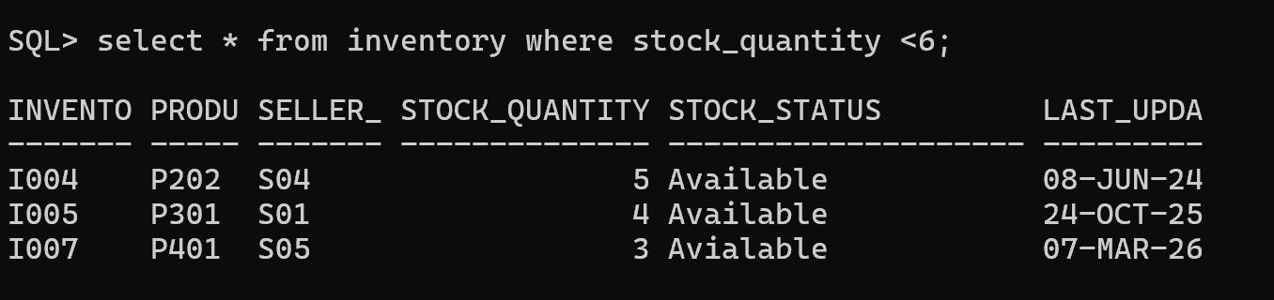

6. Retrieve Customer and Product Information
- Display customer details with their orders.
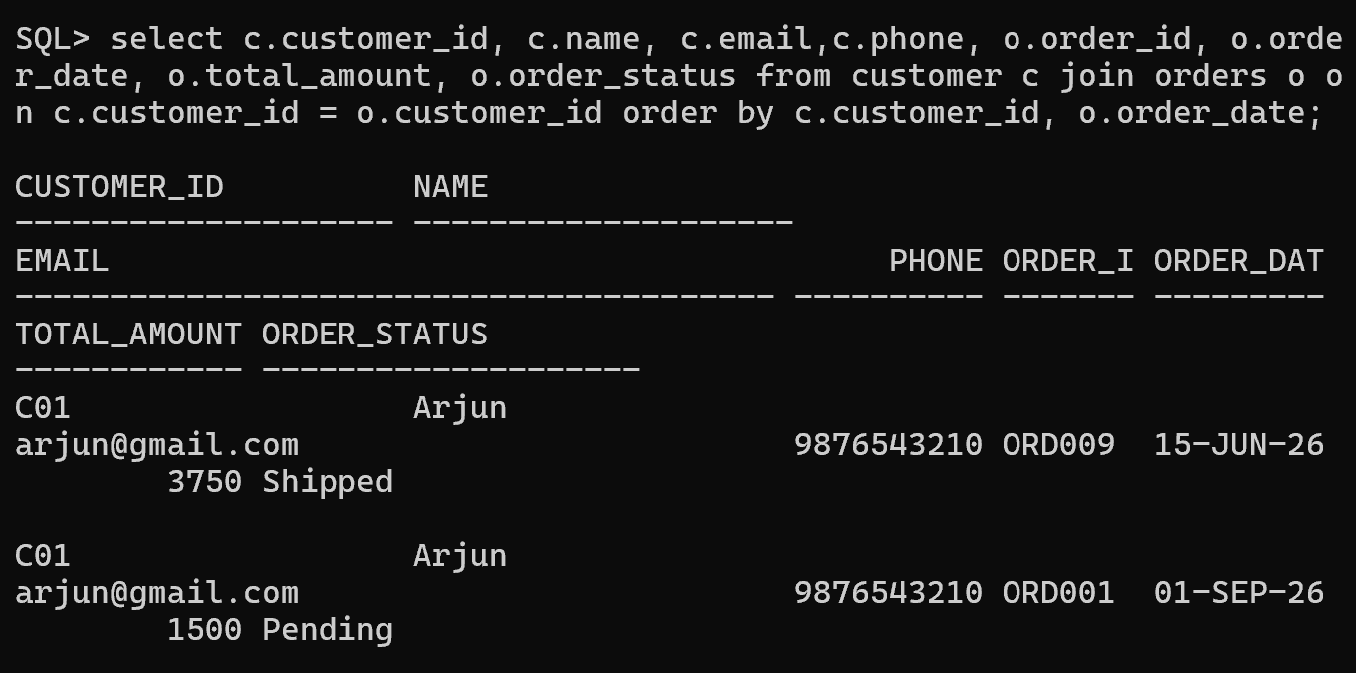
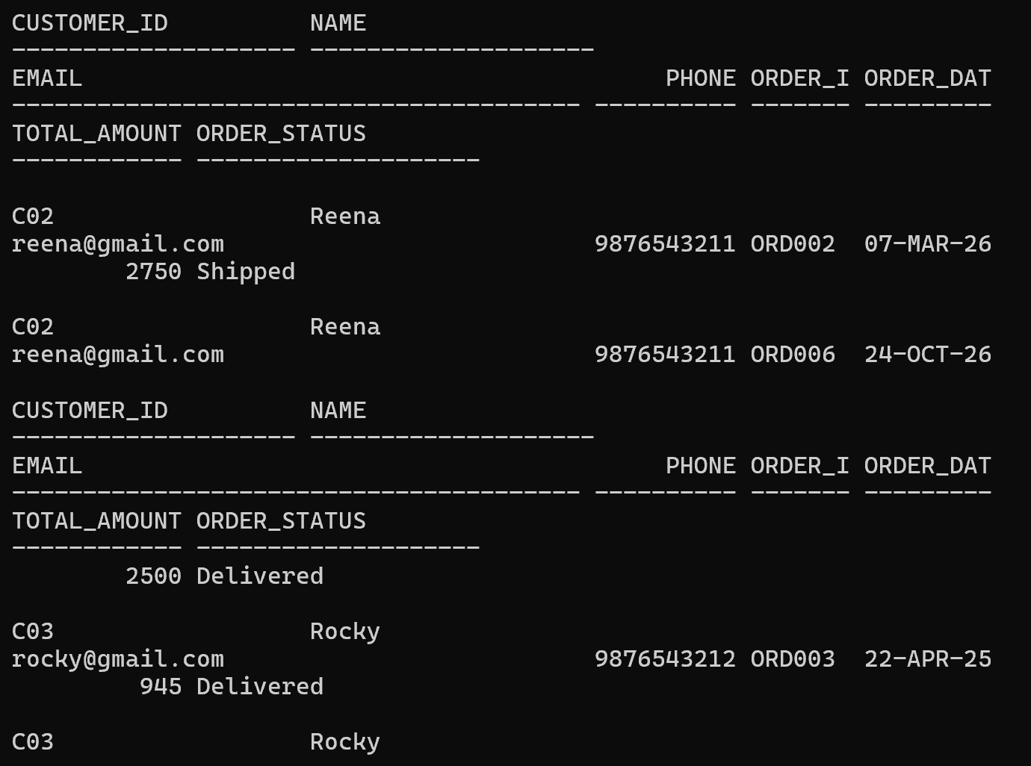
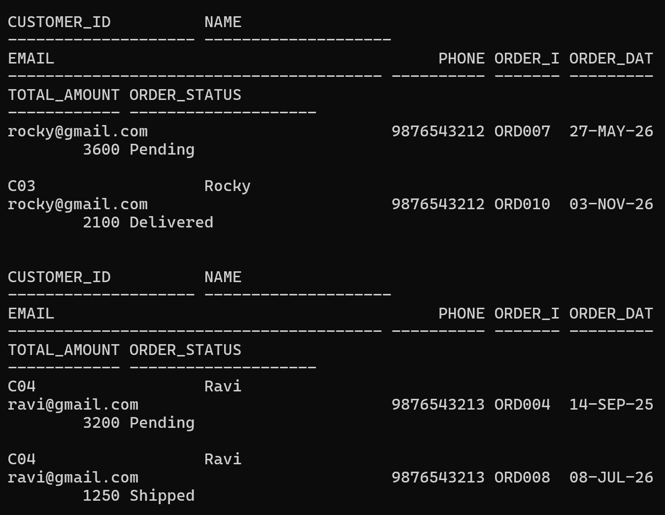
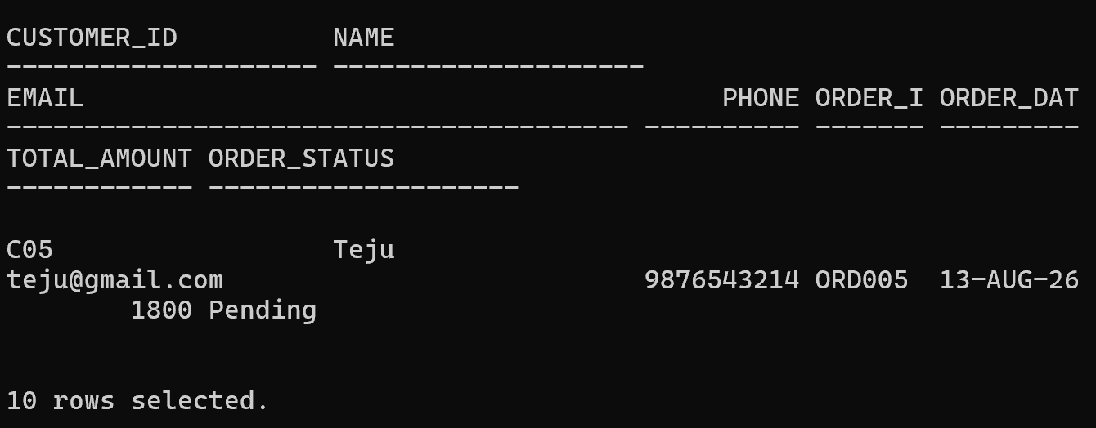
- Display product details with category information.
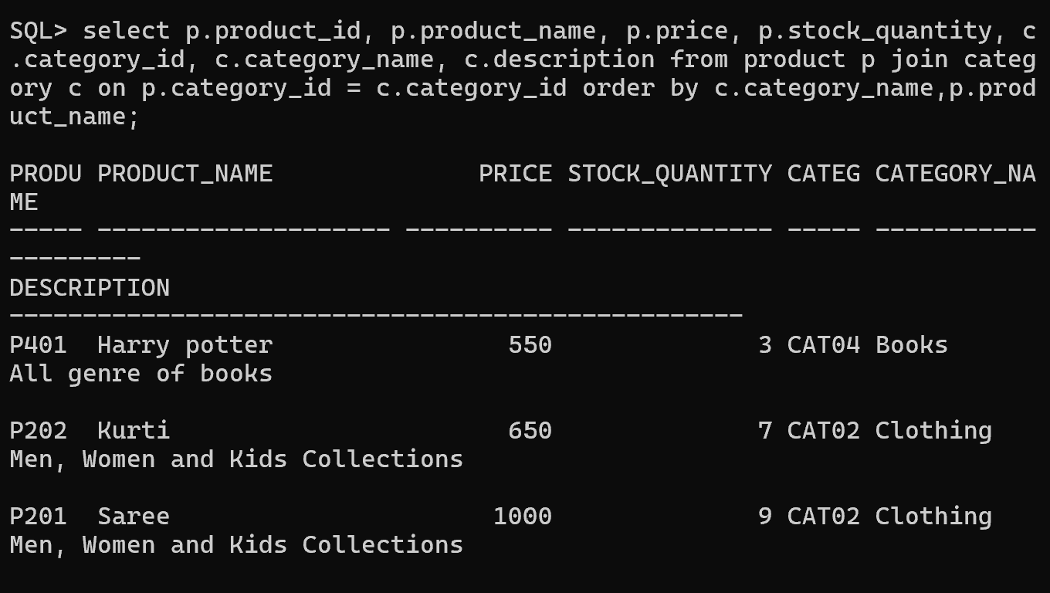
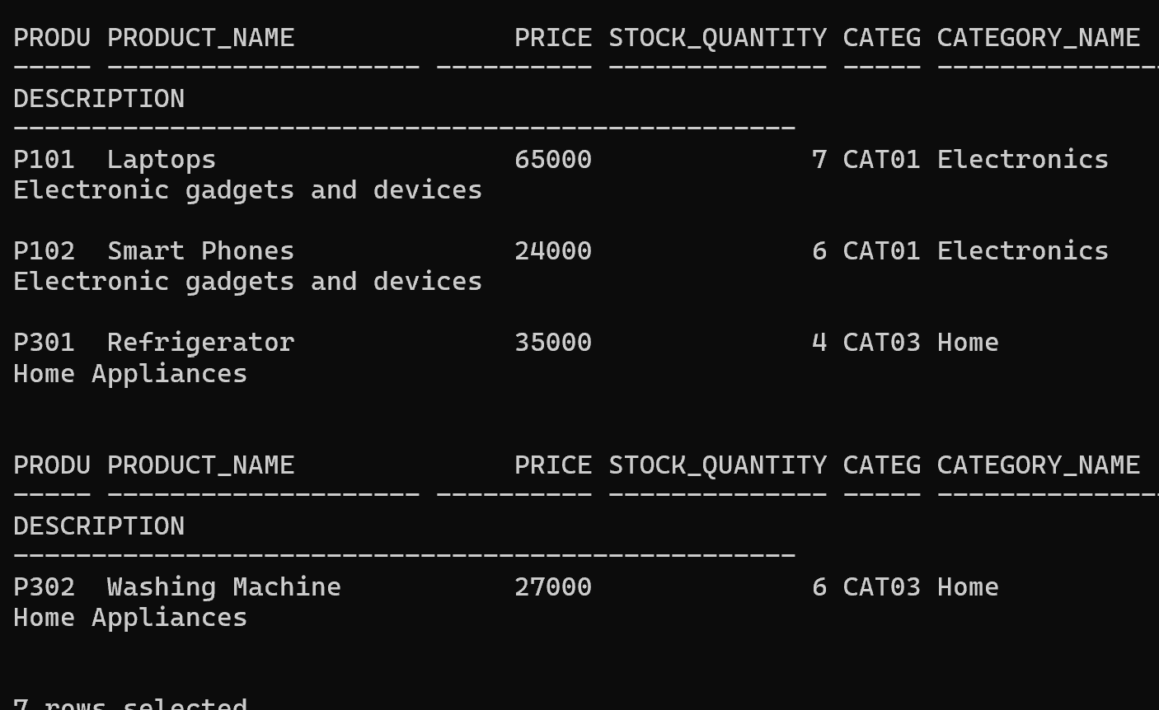
- Find customers who purchased a specific product.
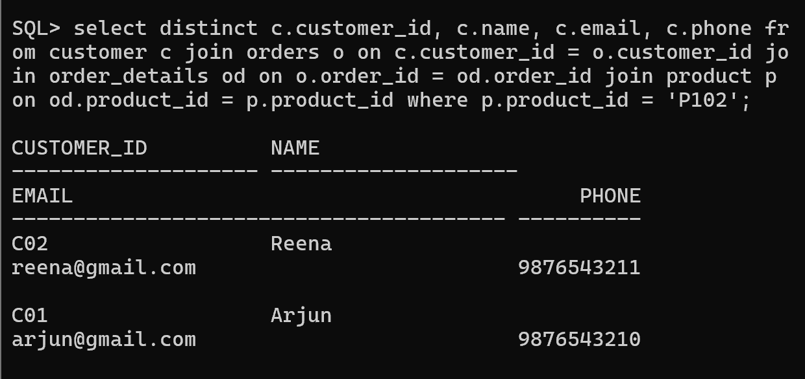
- Display products purchased by each customer.
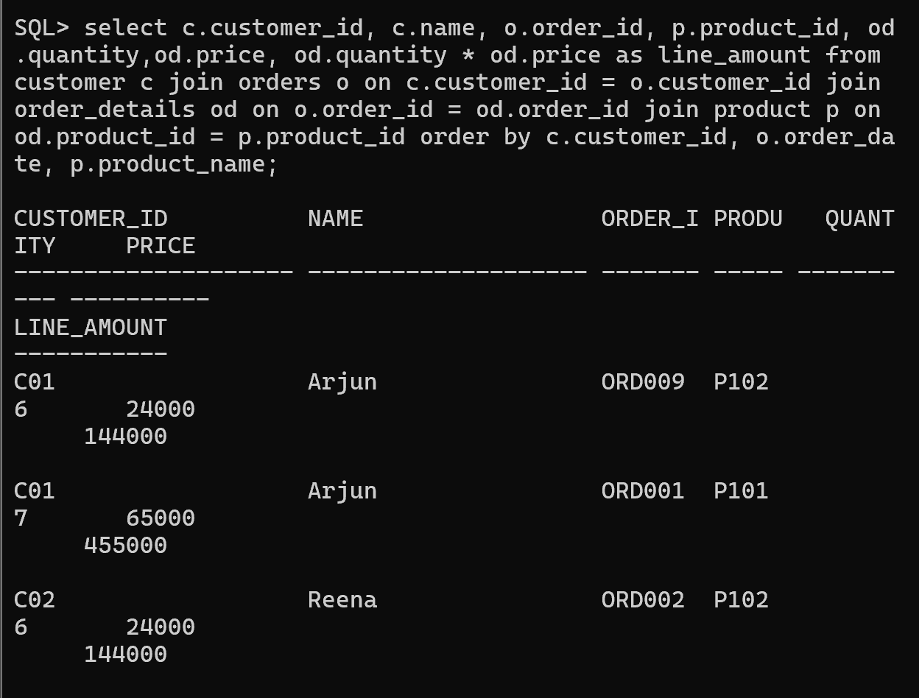
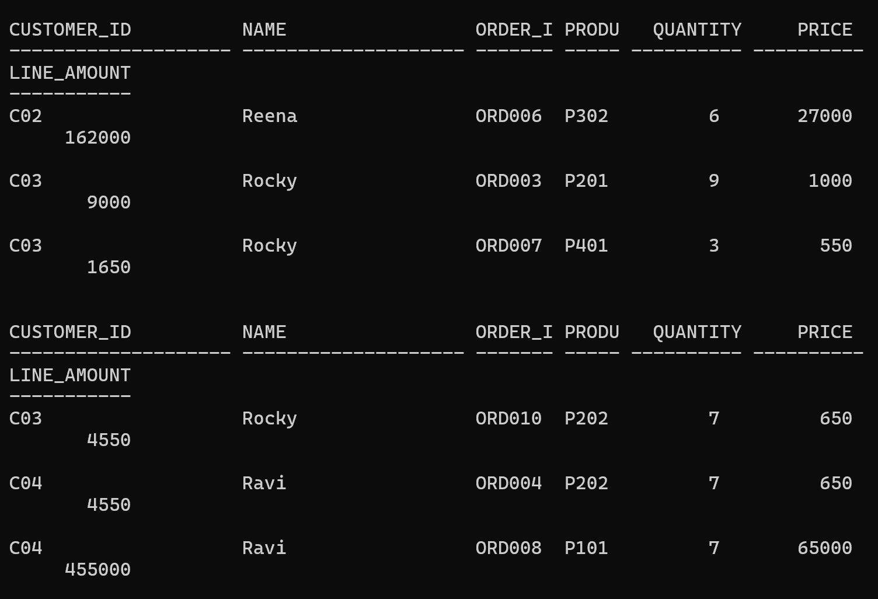
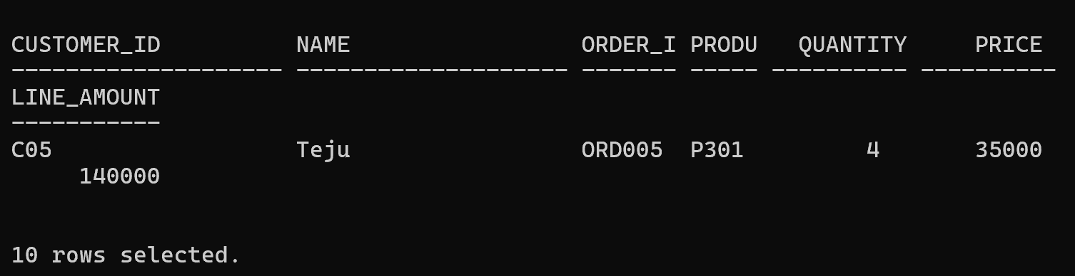

7.Apply Multiple Filtering Conditions
- Find electronics products costing more than ₹10000.
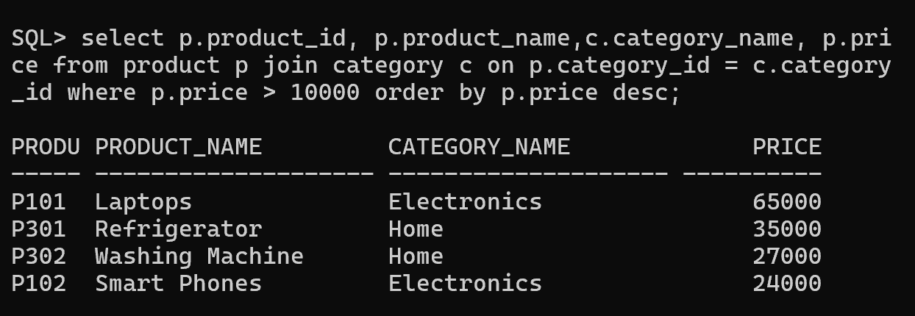
- Search products containing the word MOBILE".
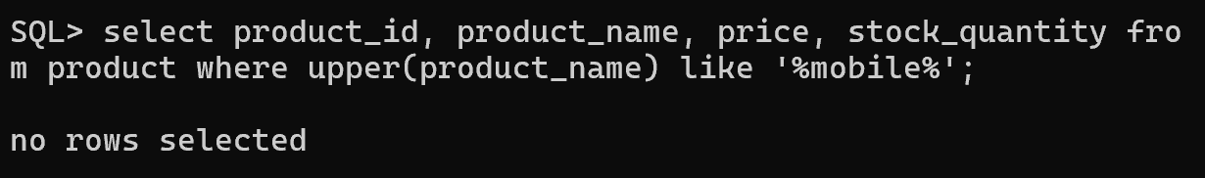
- Find orders placed within a specific date range.
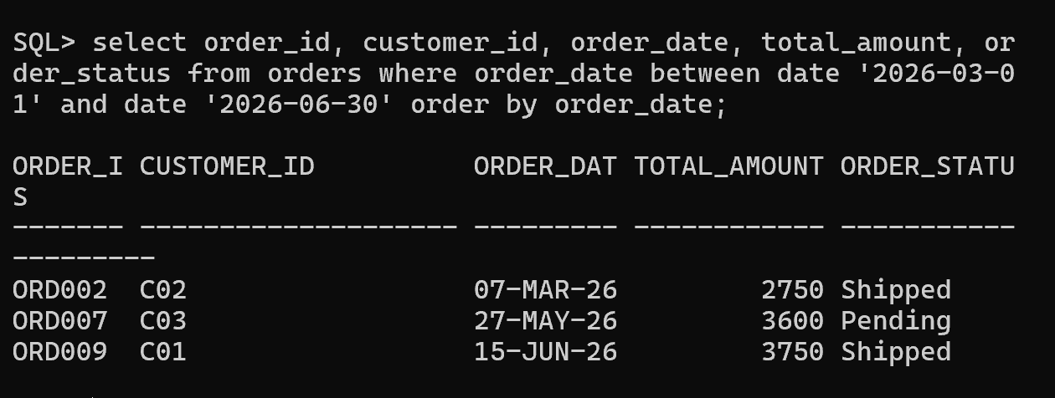
8.Generate Basic Business Reports
- Report 1: Product Availability Report
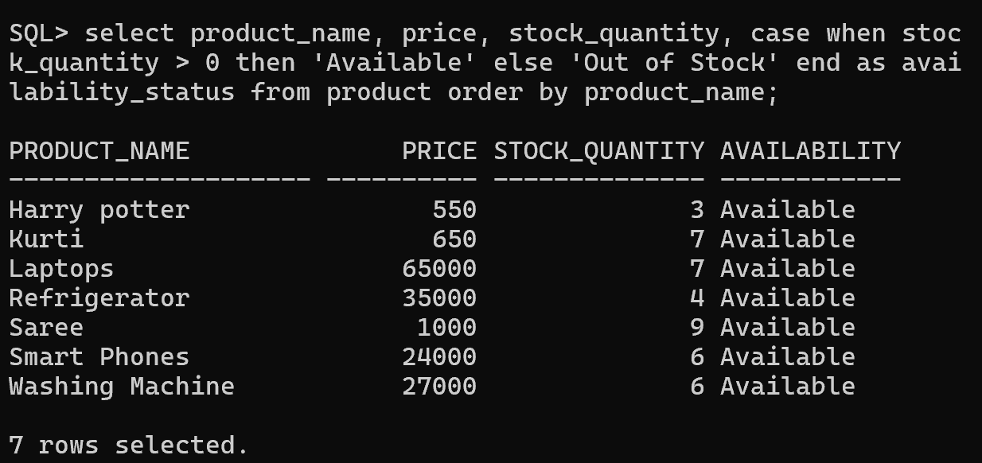
- Report 2: Customer Report
Total number of customers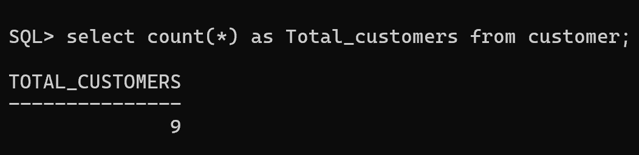
New customer registrations
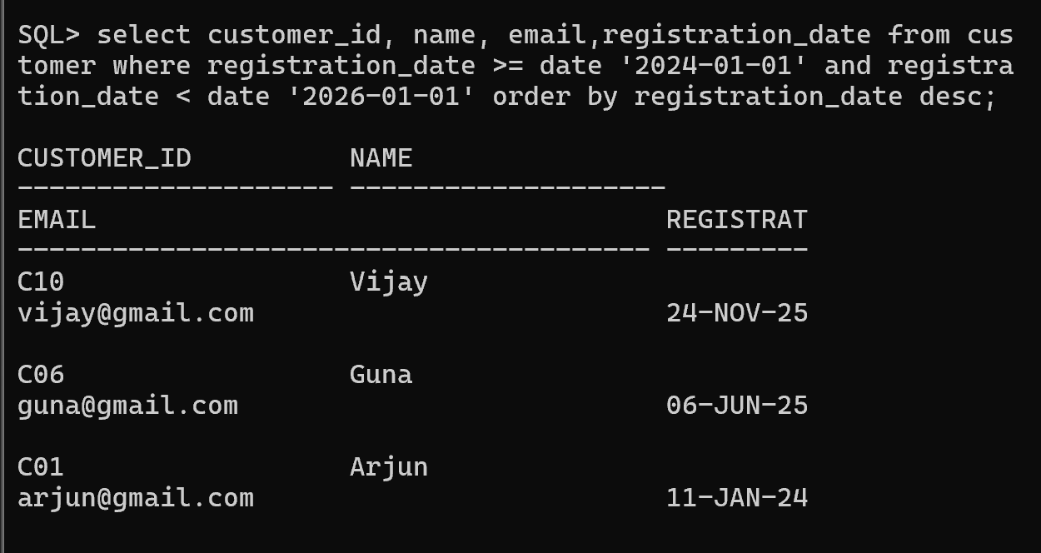

- Report 3: Order Report
Total orders
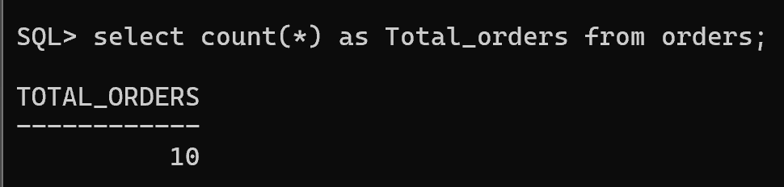
Completed orders
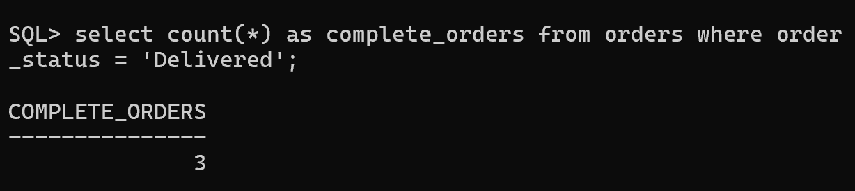
Pending orders
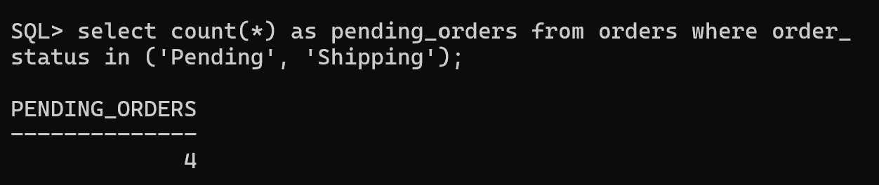
Cancelled orders
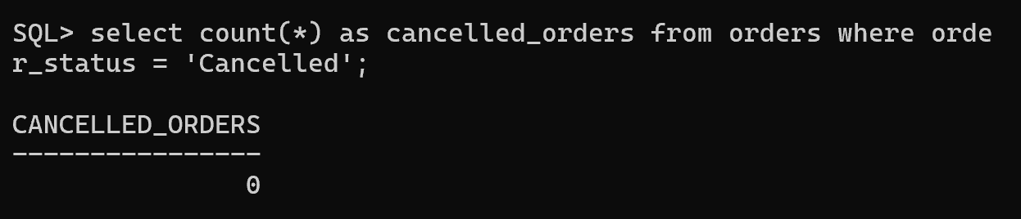
- Report 4: Product Performance Report
Highest-priced products
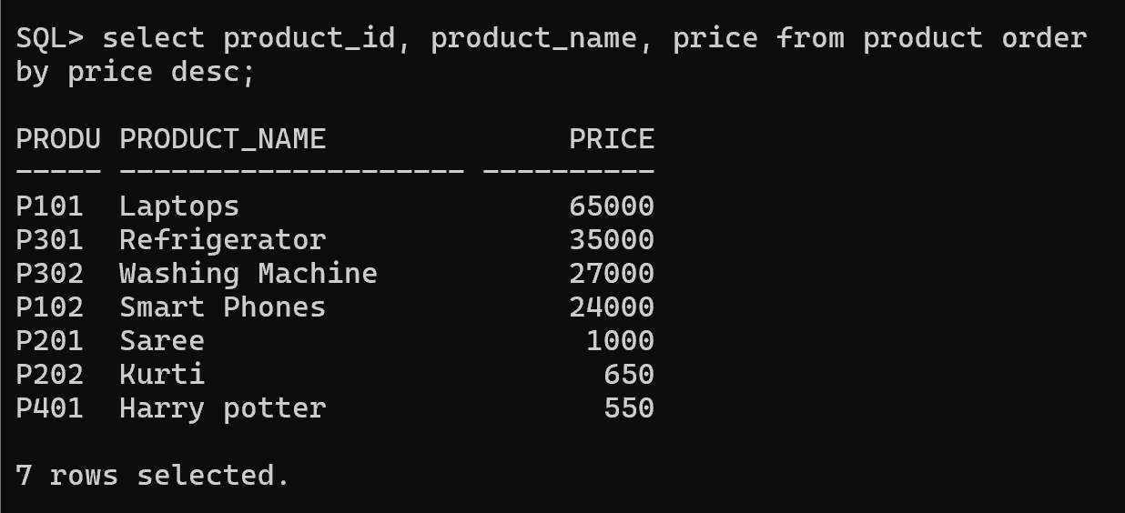

Most reviewed products
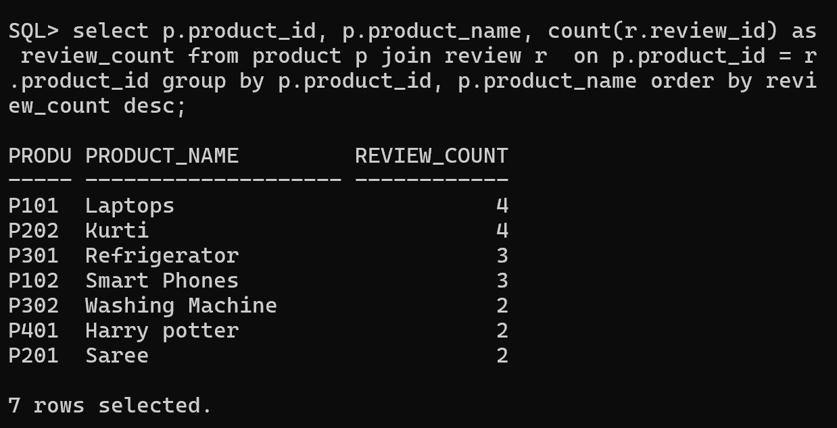
Available products
